**Team 3: Vanessa (Vin) Martinez, Michael Mederos, Corey Knighten**

**Project 6.2 Semester Project Proposal**

**CIST2745 Intro/Artificial Intelligence**

**Professor Trevor Goodyear**

**9/29/19**

**Game Proposal:**

**Game**: Asteria

**Genre:** Fantasy Adventure

**Rating:** E10+

**Player Goals:** Gather all elemental artifacts to clear a stage, avoid being killed by the enemies, the player can kill enemies and will get bonus points for clearing enemies.

Once a stage is clear there is a boss battle.

( The player does not have to kill all enemies to advance, as mentioned, the main goal is to collect the artifacts to clear the stage, however the player will have a higher score/more coins for killing or clearing the enemies.)

**Player:**

Asteria (Third Person, Over the Shoulder Camera Angle)

**Enemies:**

Nightmare Wraith (Boss) (Behavior Tree and Fuzzy Logic)

Mushroom Creatures (Flock AI Enemies)

Dark Elf Mages (Pathfinding Enemy)

Chaos Knight (Pathfinding Enemy)

**Story:** Asteria is a young Dream Fairy of Ehathra. Ehathra have become imbalanced with corruption spreading through its land – all caused by the Nightmare Wraith To bring balance back, Asteria must gather what have been stolen and defeat the Nightmare Wraith.

**Other Published Games with Similar Gameplay Mechanics/Theme:** Spyro, The Legend of Zelda

**Specific AI implementations:**

**How does the game implement any of the concepts we have discussed in class?**

**Other AI concepts not covered in class also welcome but need to include at least 3 of the following**

There will be 3 enemy types and 1 boss. The three enemies will be Mushroom Monsters, Chaos Knights, and Dark Elf Mages. The one boss is the Nightmare Wraith.

The Mushroom monsters will be the weakest enemies, they can be easily killed in one shot, hence why they will be flocking together as a crowd when attacking the player. The AI implementation will be Flocking, just how in our Flocking Unity Lab, the mushroom monsters will all have one goal to go attack the player when they go near a spawning area of theirs. The spawning point will be invisible, hidden in a tree.

Level “5” Enemy will be the Dark Elf mage, by level 5, it means unlike the mushroom monsters dying easily with one hit, they will take 5 hits to die. There will be about 5 mages roaming around. They will have the AI implementation of Pathfinding, Sensors, and Behavior Trees. The Dark Elf Mage will attack from a distance, they will have limited speed and can’t go up hill.

Leve “10” Enemy will be the Chaos Knights, by level 10, it means it will take 10 hits to kill them. There will only be 2 Chaos Knights Roaming Around, they will have a faster speed and ability to go up hills/terrains. Just like the Dark Elf mages, Chaos Knights will have Pathfinding, Sensors, and Behavior Trees.

Both the Dark Elf Mages and Chaos Nights will need to navigate around obstacles such as the trees and rocks and have a certain path they will follow to get to the player. They will have to use Sensors to detect where the player is. For the Mages they need to especially know so what distance they will stop and attack. As for the Knights, they have only one goal to keep attacking the player.

Now, for the Boss. Once the player has gathered the artifacts, the stage is cleared, and she can go to the Boss Scene. Where its only the player and the boss, the Nightmare Wraith. It will be one main stage, and about 4-5 platforms. The stage and platforms all baked to a nav mesh, and there will be off-links from the stage to platforms and between the platforms for the Player to move around the boss. The boss will be in the center of the stage the whole time, she will have the AI implementation of Behavior Trees and Fuzzy Logic. She must strategize when to attack the player and locate where the player is as they move from each platform. The Boss will have a melee attack and magic based attack, she will also be able to defend herself once her health is at a low health threshold.

**Concept Art/Marketing Art:**

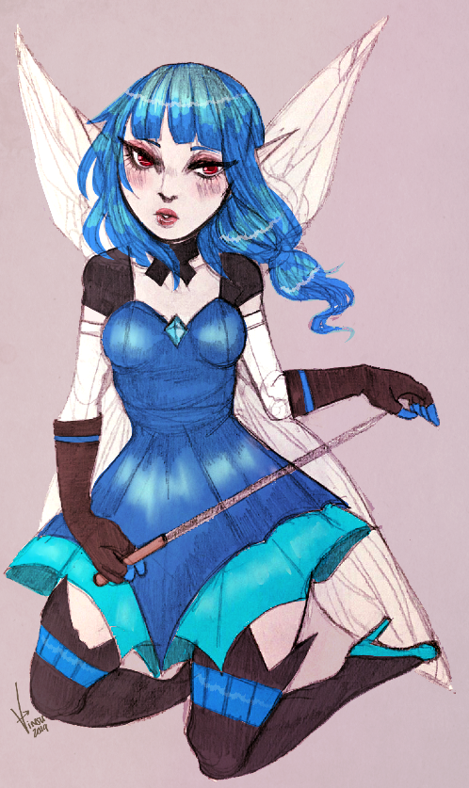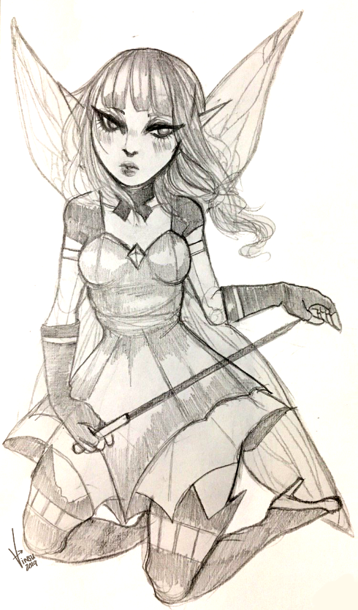

Player Concept Art: “Asteria” By: Vin | Character Design Based off “Lady Fairy” Model from MESHSMITH in the Unity Asset Store

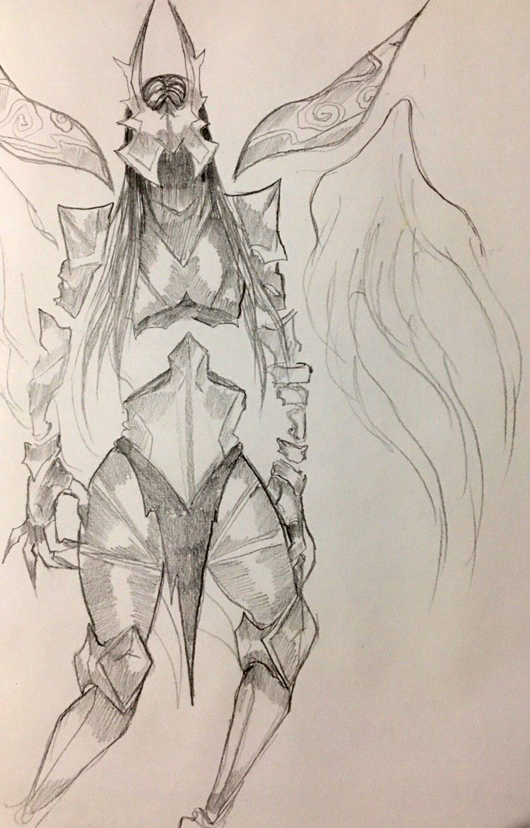

Boss Enemy Concept Art: “Nightmare Wraith” By: Vin | Character Design Based off “Fallen Angel” by RAINENTERTAINMENT from the Unity Asset Store

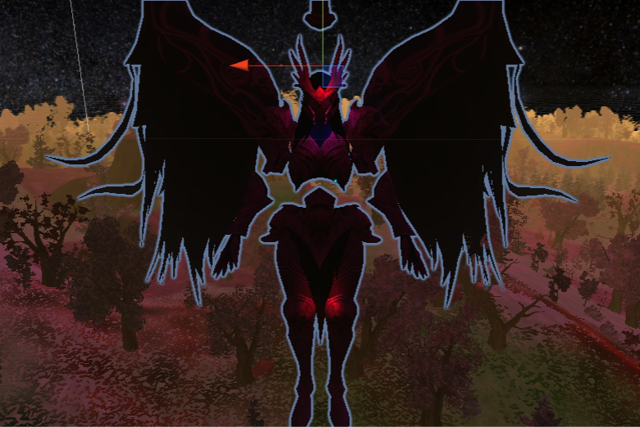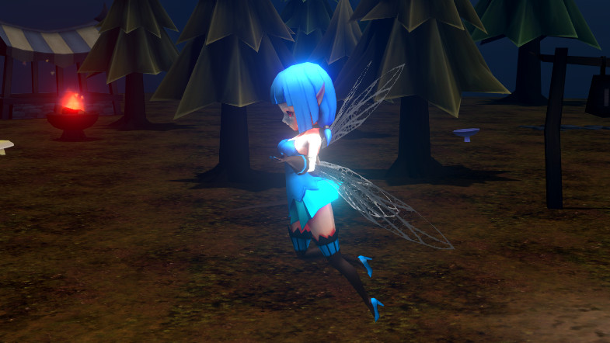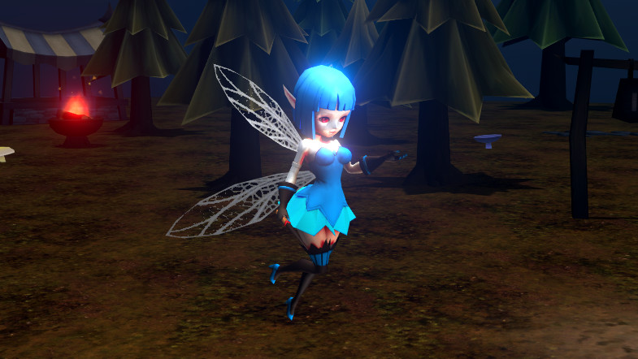 Character Design and Model: “Lady Fairy” by MESHSMITH from the Unity Asset StoreCharacter Design and Model: “Fallen Angel” by RAINENTERTAINMENT from the Unity Asset Store

**TEAM MEMBERS TASKS:**

**Vin Martinez:**

**Vin Notes: “**This Project have been a discussion among our team members on and off during the summer, prior to class even beginning. We decided even before the mention of the semester project to get started on it. I have already set up the Game’s main menu scene and the main scene of the Game.”

“Asteria has her own animation controller, player controller script, health script that I, Vin, have worked on. She can fly forward and back, she has a 360 camera to easily turn. She even has her attack animation working when the space key is pressed. I have set all that is shown here up so far.

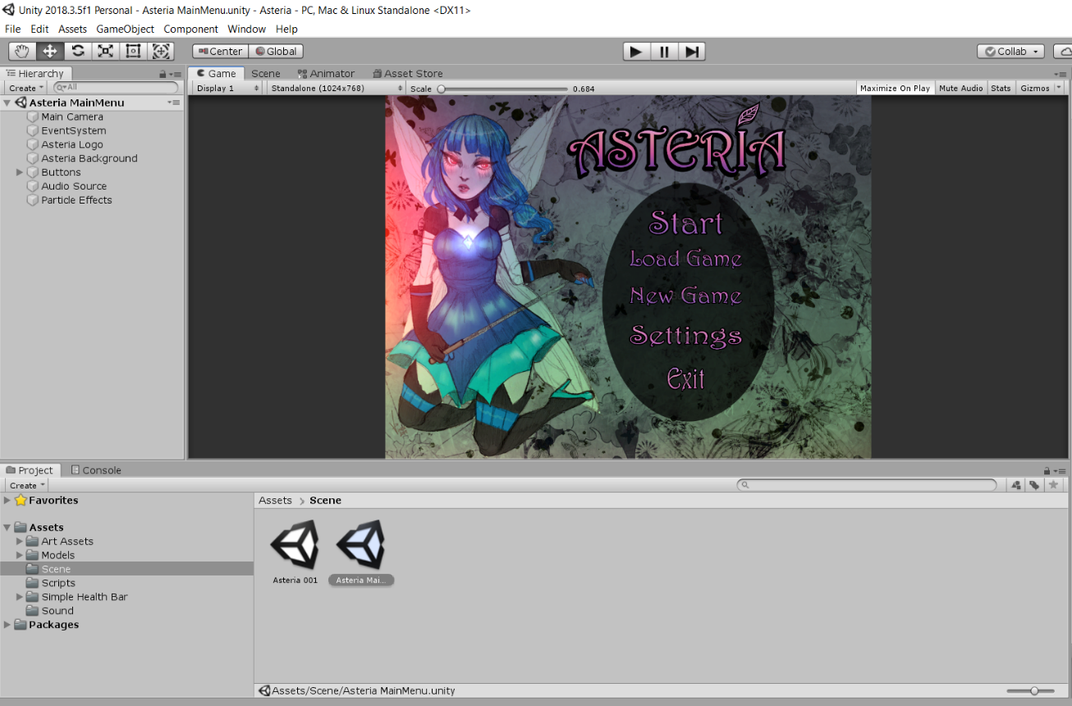My Next task shall be improving the player’s control, AI of certain moving obstacles, and AI of the Boss Enemy.”

Main Menu Scene, Design, & Art By: Vin

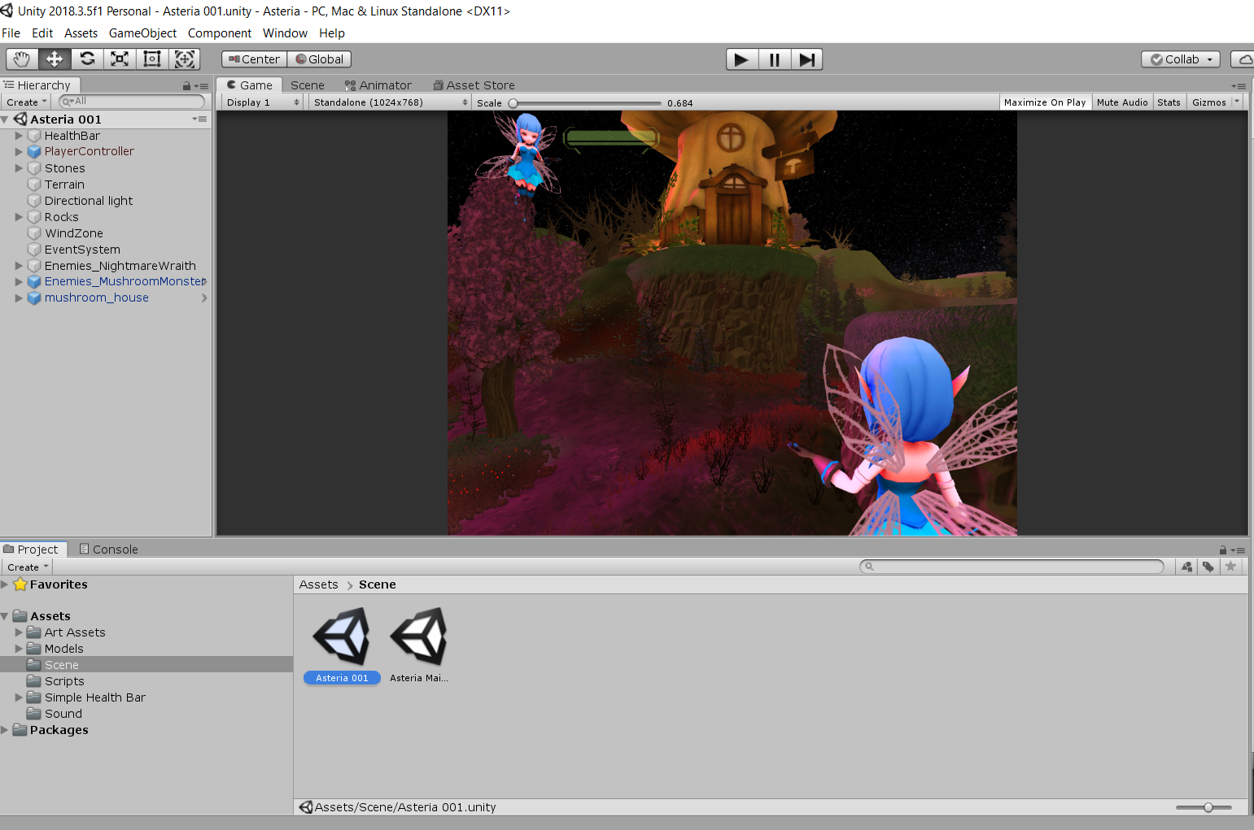

Asteria Gameplay Preview| Setup By: Vin

**Michael Mederos:**

**Michael Notes**: "Our team as has worked together on prior project in our Game Development and Game Physics classes, so we have a good understanding on what each of us are more comfortable doing. My main objective is working on the Boss Scene where the player and various enemies will be moving from platform to platform while the Nightmare Wraith is at the center attacking. I'll also be assisting in the pathfinding for the enemies of the game and adding sound to the game."

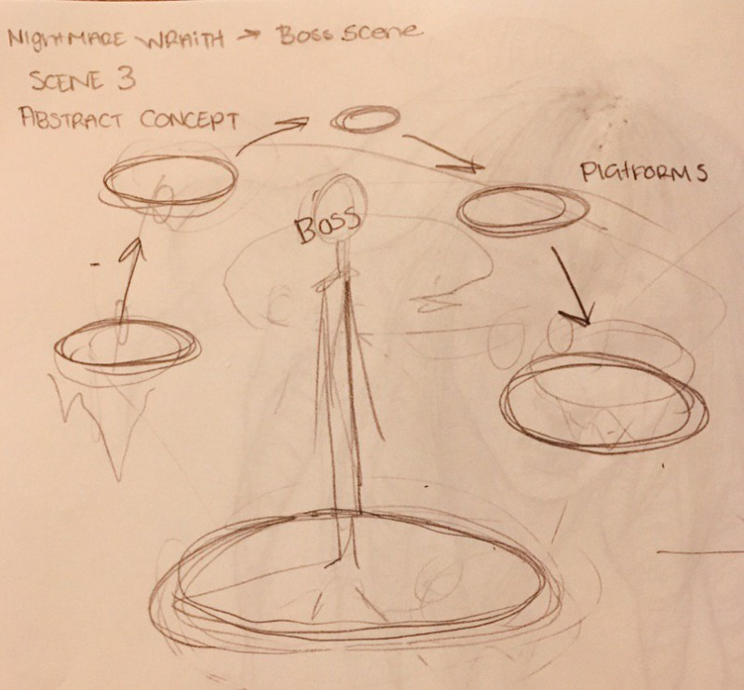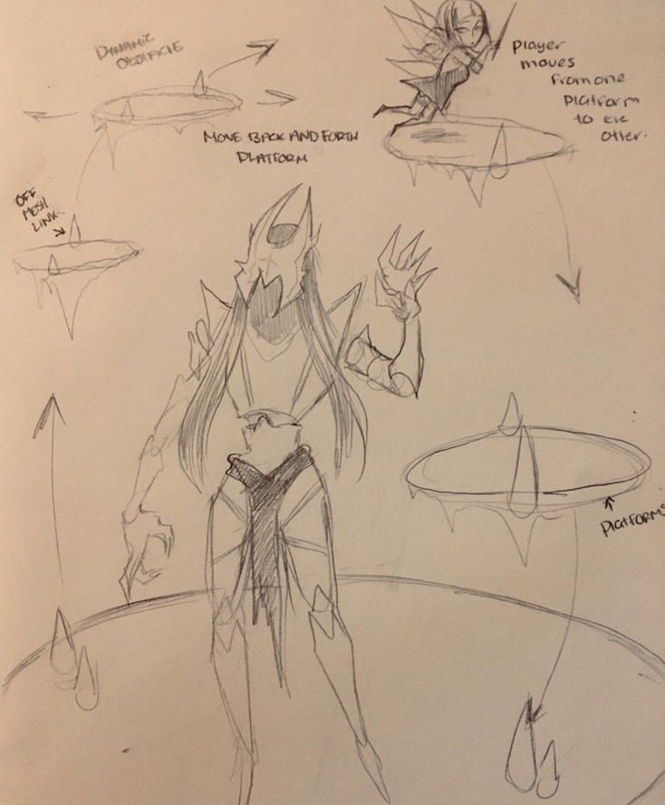

Boss Scene/Level Design Collaborated as a Team | Rough Concept Sketch By: Vin

**Corey Knighten:**

**Corey Notes:** “ Will be working on the Enemy Flock AI for the Mushroom Monsters which are one hit enemies, and the AI of the medium level enemies of the Dark Mages and Chaos Knights. Pathfinding and Behavior Trees will be use, so will be working on adding a Nav Mesh to the scene to bake.“

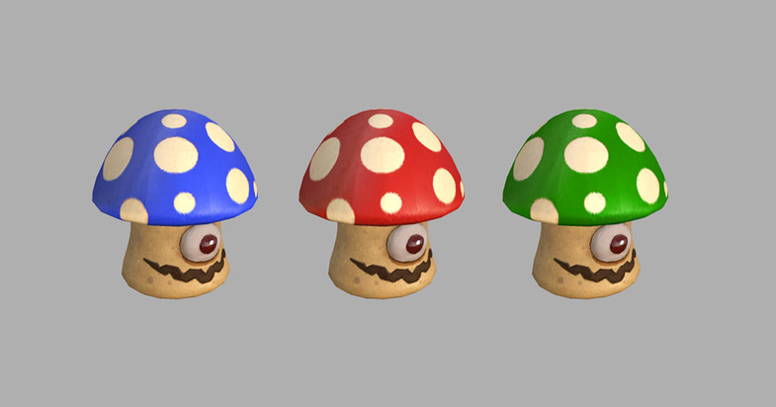

Enemies “Mushroom Monsters”, Asset by: AMUSEDART on the Unity Asset Store

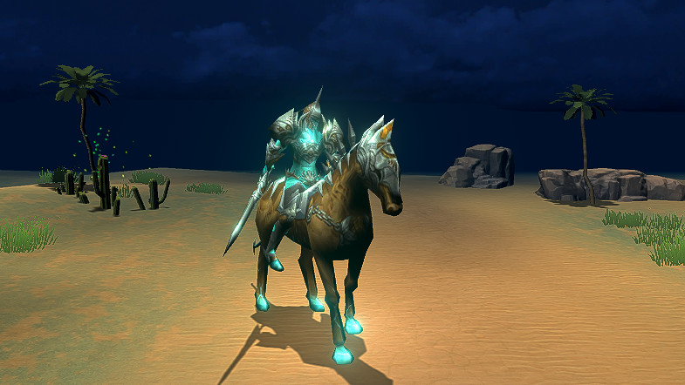

Enemies “Chaos Knight”, Asset by: RAINENTERTAINMENT on the Unity Asset Store

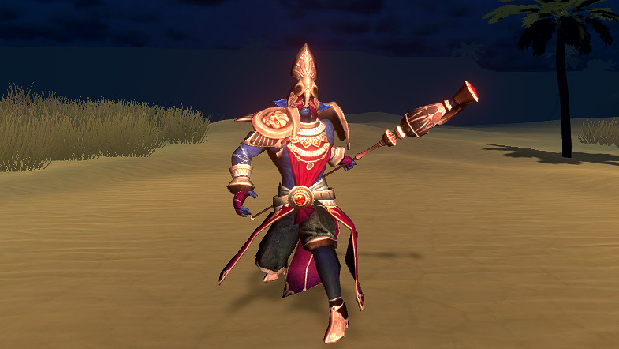

Enemies “Dark Elf Mage” , Asset by: RAINENTERTAINMENT on the Unity Asset Store